WIDE BAND AMPLIFIER

Specification:
- frequency range: 50Mhz-3000Mhz
- Gain : 33 +/- 2.5 dB
- return loss: 10 dB min @ > 150MHz ,
7dB min @ < 150MHz
- P out 1dB compression : 4 dBm min
- D.C. input : < 50 mA @ 8 to 28 V

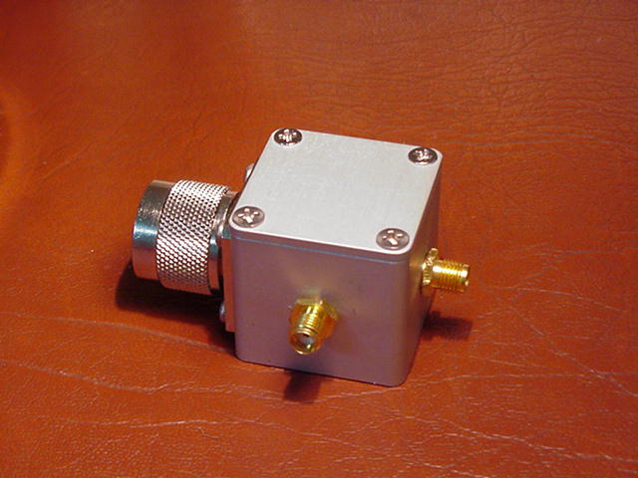
2003/7/25

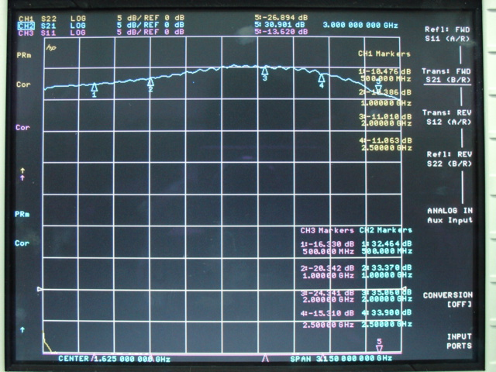
Fig1. S21 : gain
S11 : input return loss , S22 : output return loss

